CompHydro Baltimore Student Pre-Assessment
Items

Hydrology
- Sports Field
- Parking Lot
Modeling
- Models questions
- Models Problem
- Models Evaluation
Topography
- Topo Interpolation
- Pine Creek Flow
- Topo Gradient
Hydrology Part 2
- Water Flow to stream gauge
Hydrographs
- What is a hydrograph
- Explain
- Explain Data
Rainfall Interpolation
- Estimating Rainfall at X
- Rainfall estimation confidence
Hydrology Part 3
- Vegetation reducing flooding
Caring
- Flooding Caring
Modeling Importance
- Modeling Importance
Gender
- Gender

HYDROLOGY
The picture below shows part of a school campus with several grassy sports fields and a parking lot near a river. Use the picture to help you answer the next set of questions.
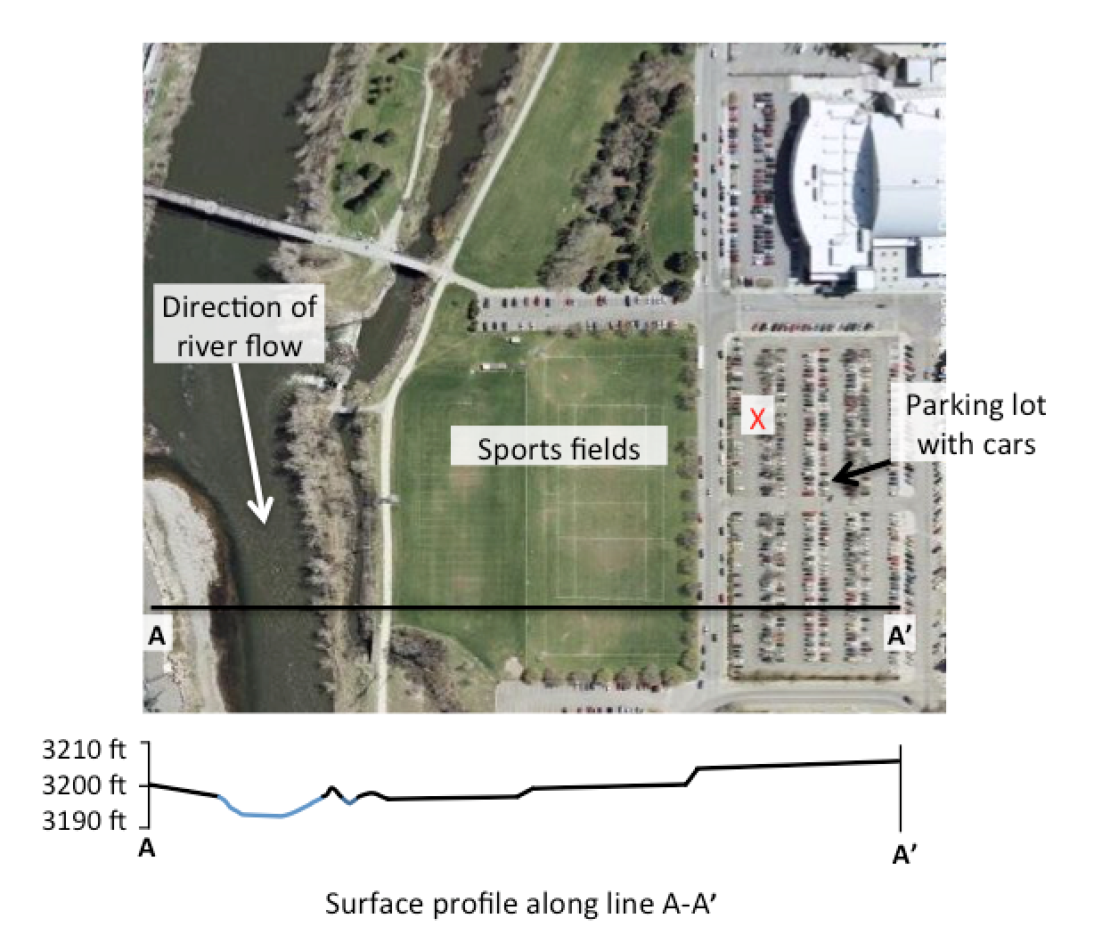
SPORTS FIELD (Pre & Post)
1. Could water falling on the sports fields as rain get into the river?
  - (Choose 1) YES NO
  - If you answered “yes,” explain how and why you think the water could get into the river. If you answered “no,” explain why the water could not get into the river. Please provide as many details as you can.

PARKING LOT (Pre & Post)
2. Could water falling on the parking lot as rain at the location marked with the X get into the river?
- (Choose 1) YES NO
- If you answered “yes,” explain how and why the water could get into the river. If you answered “no,” explain why the water could not get into the river. Please provide as many details as you can.
MODELING
MODELS QUESTIONS (Pre & Post)
3. a. What do you think scientists use computer models for?
b. Write a question about a real world water problem related to contamination or flooding that a scientist could use a computer model to answer.

MODELS PROBLEMS (Pre & Post)
4. What are some problems with using a computer model to understand a real world water problem?

MODELS EVALUATION (Pre & Post)
5. How can a scientist judge if a computer model is accurate?

TOPOGRAPHY
Surface Elevations (Map interpretation and Data Interpolation –D)
Use this contour map of a land surface to answer the questions below.

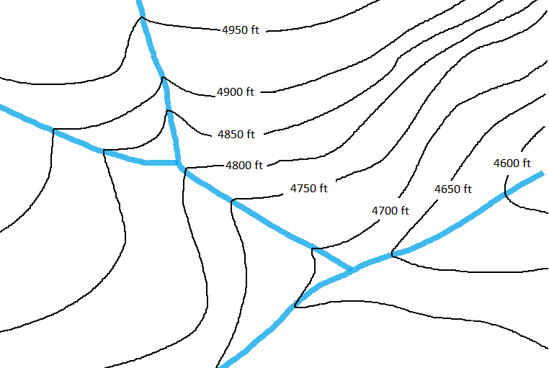
X
Oak Creek
N
S
E
W
B

Pine Creek
C
D
A

TOPO INTERPOLATION (Pre & Post)
6. a. What would be a reasonable estimate for the elevation of the land surface at the X on the map?
- 4800 ft
- 4850 ft
- 4815 ft
- 4765 ft
- Please explain why you chose that answer.
PINE CREEK FLOW (Pre & Post)
7. a. Which direction is Pine Creek flowing?
b. Explain how you decided on your answer.

TOPO GRADIENT (Pre & Post)
8. a. Where is the slope of the land the steepest?
- A
- B
- C
- D
b. Please explain why you chose that answer.

HYDROLOGY PART 2
Scenario
The West Branch of Herring Run watershed lies just north of Baltimore City. The watershed (outlined in black) has a mix of land uses as you can see in the following aerial image. A stream gauge is placed at the downstream end of the West Branch of Herring Run to measure how much water passes through that point in the stream over time. A rain storm passes over the watershed.

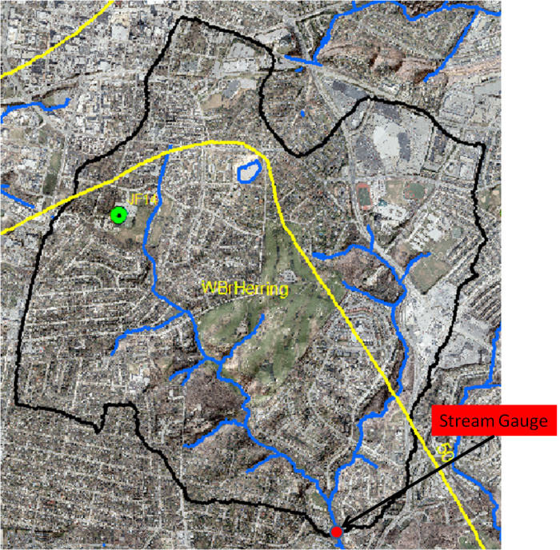
WATER FLOW TO STREAM GAUGE (Pre & Post)
9. a. What features of the watershed influence how much water gets to the stream gauge? List as many features as you can think of.
b. What features of the watershed influence how fast the water gets to the stream gauge? List as many features as you can think of.
HYDROGRAPHS
The hydrograph below shows data from the stream gauge on the West Branch of Herring Run for a 60 minute (one hour) period one August afternoon. Use this graph to answer the next three questions. Pre and Post

Rate of Flow (cubic feet per second)

  - What does the blue line on this hydrograph represent? It’s ok to select more than one answer.
- The total amount of water in the West Branch stream at the time shown.
- The elevation of the water at a location in the West Branch stream at the time shown.
- The rate at which water is passing a location in the stream at the time shown.
- How long it takes water that falls as rain to leave the watershed.

  - Explain why you selected the answer or answers you did.
  - Explain what you think caused the data to show the pattern you see in the hydrograph.

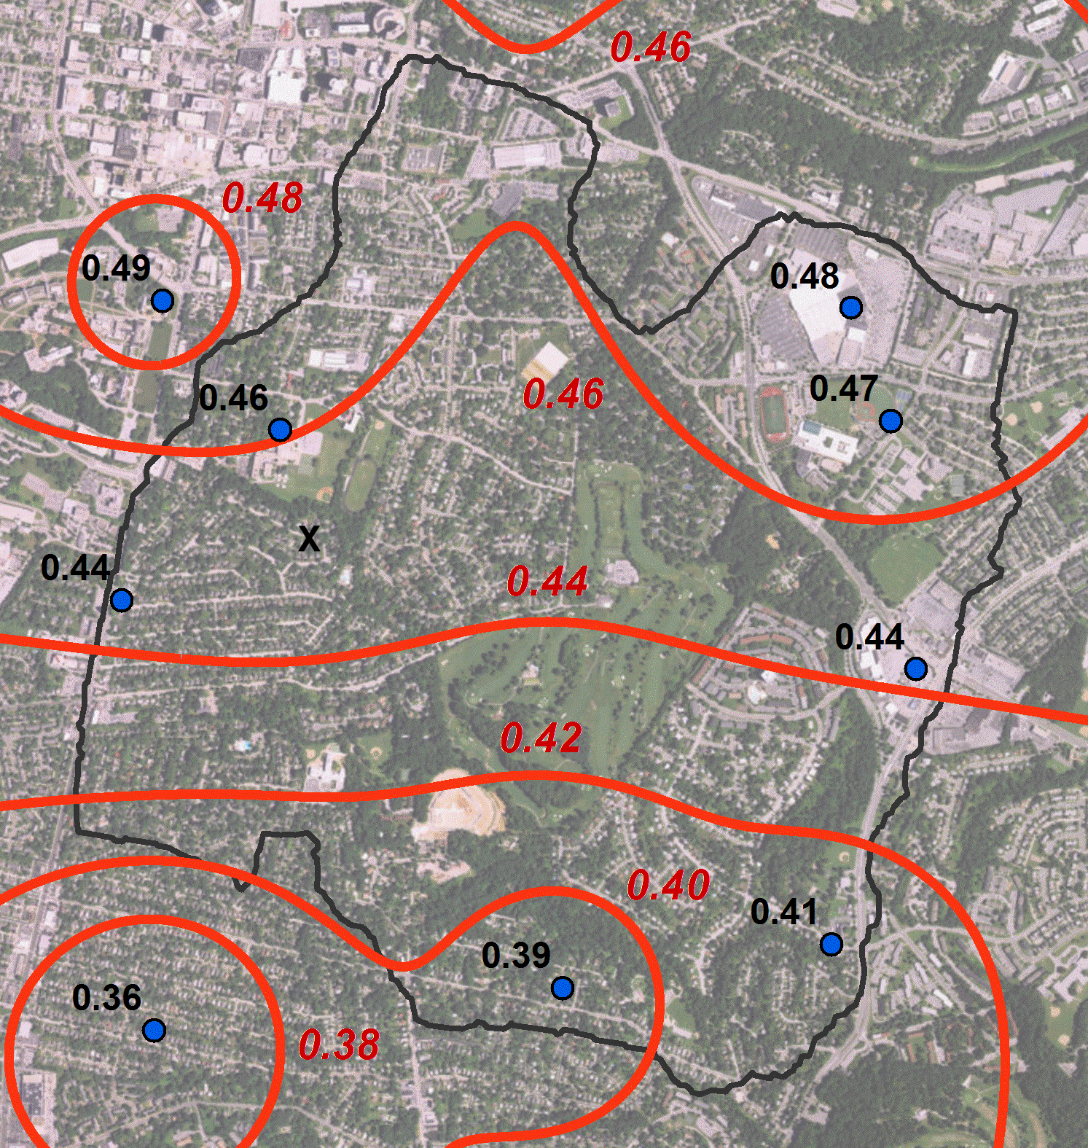
RAINFALL INTERPOLATION
Y

The West Branch of Herring Run Watershed is outlined in black on this air photo of suburban Baltimore. The blue dots show the locations of 9 rain gauges in the area, and the numbers are the amount of rain measured in cm in each gauge after a single thunderstorm. These values were used in a computer program to draw rainfall contour lines, which are shown in red.

Part 1. (Interpreting contours and uncertainty.)
13. What would be a reasonable estimate of the rainfall at point X? (interpolate )
  - Please explain your thinking for giving that answer.
14. At which of the two locations – X or Y – would you be least confident about the rainfall estimated by a computer model using the data from the rain gauges on this map?
  - Please explain your thinking for giving that answer.

HYDROLOGY PART 3
VEGETATION (Pre & Post)
Baltimore City is trying to reduce the likelihood of runoff and flooding in Baltimore.
- One approach they are taking is to increase the amount of grass, shrubs and trees in city neighborhoods. What are some reasons why they would make this recommendation as a way to reduce flooding?

For each question, rate your level of agreement. (Use a 5 point scale from Not At All Important to Extremely Important)

CARING
16. How important is it to you to understand about runoff and flooding in your community?
A. Not at all important
B. Slightly important
C. Moderately important
D. Very important
E. Extremely important
b. Please explain your reason for your answer.
MODELING
17. How important is it to you that you understand how computer models can be used to address real world problems like groundwater contamination or flooding?
A. Not at all important
B. Slightly important
C. Moderately important
D. Very important
E. Extremely important
b. Please explain your reason for your answer.

GENDER
- (Optional) To help us understand how our project is serving all students, please tell us your gender. Thank you for taking this question seriously. (If you do not want to report gender, please type your answer as N/A).

