Baltimore Data Jam: pH Metadata
The Baltimore Ecosystem Study, BES, is a Long Term Ecological Study funded by the National Science Foundation. Their goal is to conduct long term research at ecological sites in Baltimore City and the surrounding areas. They broaden the idea of ecology to not only focus on the natural world, but include the people and the cities they live in, to better understand their role in the environment.
- Dataset Variables:
  - Date: calendar date sample was taken
  - Location: location following data was taken from (BARN=Baisman Run)
  - pH: pH value of sample
  - Date: calendar date sample was taken
  - Location: location following data was taken from (GRGF=Gwynns Run at Gwynns Falls)
  - pH: pH value of sample
- Dataset Timeframe
  - Dataset includes weekly samples for the year 2014.
  - Additional data is available for these and other sites for more than 15 years, starting in 1998.
  - The data were published 4/5/16.
- Data Collection Methods:
  - Samples were collected by BES staff with clean plastic bottles from the same location in each stream every week.
  - Cl concentrations were measured in the laboratories of the Cary Institute.
- Information About Sites
  - Baisman Run is located in Baltimore County in Oregon Ridge Park. The 381 hectare watershed is mostly forested with a small number of large residential properties at the top of the watershed. The stream gauge is located at Ivy Hill Road underneath the bridge.
  - Gwynns Run at Gwynns Falls sample site is located in Carroll Park. Carroll Park is located in Baltimore City in the Carroll Park Municipal golf course. The watershed is approximately 2.5 square miles and is considered an urban subwatershed. Denitrification efforts have taken place to help improve the the quality of the stream.
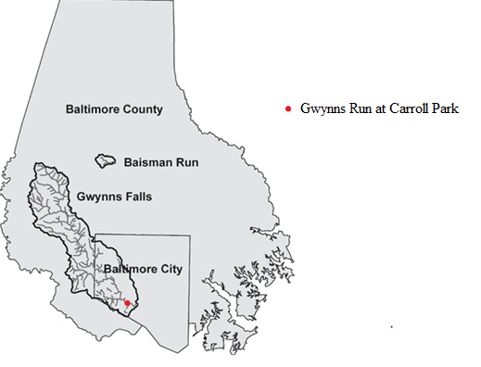
- Contact Person for Dataset:
  - Dr. Peter Groffman, BES Co-Principal Investigator, (845) 677-7600 x128, groffmanp@caryinstitute.org
  - Web information at: http://www.caryinstitute.org/science-program/our-scientists/dr-peter-m-roffman
  - Dr. Groffman specializes in soil ecology and water quality. His research focuses on the role of microorganisms in ecosystems, microbial processes, and nutrient cycling within the environment.
- Background Information
  - pH is used to measure how acidic or basic a solution is. The pH scale ranges from 0-14 with lower values being more acidic and higher values more basic. The middle of the scale, 7, represents a neutral value. pH can indicate whether a solution, like water in a stream, is changing chemically, for instance, if pollutants have entered the waterway.
  - The average pH of rain is 5.6. Most pollutants lower a stream’s pH, making it more acidic and causing adverse effects to aquatic life. A common reason the pH of a stream would become more acidic include acid rain. The pH can also increase, and become more basic, or alkaline, due to lime, which is used in agriculture, construction, and manufacturing goods like paper and glass. Lime is also found naturally in limestone.
- Link to Maryland State Curriculum
  - Grade six
    - Standard 1.0, Topic B, Indicator 1.
    - Standard 6, Topic. B, Indicator 1
  - Grade seven
    - Standard 1.0, Topic B, Indicator 1.
    - Standard 6, Topic A, Indicator 1
  - Grade eight
    - Standard 1.0, Topic B, Indicator 1.
    - Standard 6, Topic B, Indicator 1
    - Standard 4.0, Topic D, Indicator 2.
- Inquiry Idea Starters
  - How does the pH differ at the two sites?
  - What are some hypotheses as to why the pH is different at the two sites?What are the trends in the data? What do you predict the pH will do in the future?
- Additional Resources
  - http://extension.usu.edu/waterquality/whats-in-your-water/ph
    - The Utah State University Extension discusses how pH affects water quality, including natural and non-natural reasons the pH of a stream can fluctuate and how pH impacts stream health.
  - https://www3.epa.gov/caddis/ssr_ph_int.html
    - The EPA describes the pH scale and what it means.

Sources
pH Water Properties. United States Geological Survey. July 31, 2016. http://water.usgs.gov/edu/ph.html
Effects on Lakes and Aquatic Ecosystems. Ohio State University, Department of Physics. Accessed July 28, 2016. http://www.physics.ohio-state.edu/~kagan/phy367/P367_articles/AcidRain/effects-on-lakes.html
Factors Influencing Stream Health. University of Hawaii. Accessed July 26, 2016.
http://www.hawaii.edu/gk-12/evo/erinb.streams.factors.htm

