Baltimore Data Jam: Rain Gauge Metadata
The Baltimore Ecosystem Study, BES, is a Long Term Ecological Study funded by the National Science Foundation. Their goal is to conduct long term research at ecological sites in Baltimore City and the surrounding areas. They broaden the idea of ecology to not only focus on the natural world, but include the people and the cities they live in, to better understand their role in the environment.
- Dataset Variables
  - Date Oregon Ridge-calendar date sample was taken at Oregon Ridge site
  - Rain (in)-measurement of rain in inches from Oregon Ridge site
  - Date Carroll Park-calendar date sample was taken at Carroll Park site
  - Rain (in)-measurement of rain in inches from Carroll Park site
- Dataset Timeframe
  - Data includes samples taken when precipitation occurs at the specific site.
  - Dates range from October 1st of 2010 until September 30th of 2011.
- Data Collection Methods
  - Precipitation data is gathered by measurements taken with a rain gauge. A rain gauge consists of a tipping bucket that measures the rain that has fallen in that area. When the bucket collects 0.01 inches of water, it tips over, emptying the water into a bucket. The number of tips that occur is noted and the amount of rain is calculated.
- Information About Sites
  - Baisman Run is located in Baltimore County in Oregon Ridge Park. The 381 hectare watershed is mostly forested with a small number of large residential properties at the top of the watershed.
  - The Gwynns Falls at Carroll Park site is located in Baltimore City in the Carroll Park Municipal golf course. The watershed that drains into this part of the Gywnns Falls includes approximately 16,000 hectares and consists of urban and suburban land. The area surrounding the site is mostly developed.
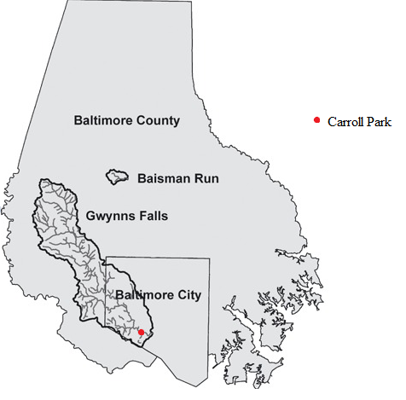
- Contact Person for Dataset
  - Claire Welty, Director of Center for Urban Environmental Research and Education, Professor of Civil and Environmental Engineering UMBC, (410) 455-1766, weltyc@umbc.edu
  - Web information at: http://userpages.umbc.edu/~weltyc/
  - Research interests include how to measure and predict the urban hydrologic cycle from small to regional scales.
- Background Information
  - On average, Maryland experiences 40 inches of rain per year. Rainfall “peaks in July and August” due to the increase in thunderstorms and the heavy rains they bring (Maryland at a Glance.) Large urban environments can potentially help aid the formation of thunderstorms, due to the warmer air that encompasses them, contributing to higher rainfall amounts.
- Link to Maryland State Curriculum
  - Grade six
    - Standard 1.0, Topic B, Indicator 1.
    - Standard 6, Topic. B, Indicator 1
  - Grade seven
    - Standard 1.0, Topic B, Indicator 1.
    - Standard 6, Topic A, Indicator 1
  - Grade eight
    - Standard 1.0, Topic B, Indicator 1.
    - Standard 2.0, Topic E, Indicators 1 &3.
    - Standard 6.0, Topic B, Indicator 1
- Inquiry Idea Starters
  - What causes the data to spike on certain days?
  - Are there any trends? Monthly/Seasonal?
  - How do the two sites compare? Does one site get more/less water than the other? Why?
- Additional Resources
  - http://earthobservatory.nasa.gov/Features/UrbanRain/urbanrain3.php
    - NASA describes how rain events differ when forming over an urban area.
  - http://earthobservatory.nasa.gov/Features/UrbanRain/urbanrain3.php
    - The Northern Illinois University explains how cities could be creating more thunderstorms than rural areas.

Sources
Gywnns Falls, Carroll Park. Baltimore Ecosystem Study. Accessed July 28, 2016. http://www.beslter.org/virtual_tour/GFCP.html
The Tipping Bucket Rain Gauge. National Oceanic and Atmospheric Association. Accessed July 30, 2016. http://www.nws.noaa.gov/asos/tipbuck.htm
Maryland at a Glance. Maryland.gov. Accessed August 1 , 2016. http://msa.maryland.gov/msa/mdmanual/01glance/html/weather.html

