Baltimore Data Jam: Nitrate Metadata
The Baltimore Ecosystem Study, BES, is a Long Term Ecological Study funded by the National Science Foundation. Their goal is to conduct long term research at ecological sites in Baltimore City and the surrounding areas. They broaden the idea of ecology to not only focus on the natural world, but include the people and the cities they live in, to better understand their role in the environment.
- Dataset Variables:
  - Site-location of sampling site
  - Date – calendar date sample was taken
  - DOY – Day of the Year (January 1 = 1, etc.)
  - NO3 (mg N/L)- Nitrate concentration
- Dataset Timeframe:
  - Dataset includes weekly samples for the year 2014.
  - Additional data is available for these and other sites for more than 15 years, starting in 1998.
  - The data were published 4/5/16.
- Data Collection Methods:
  - Samples were collected by BES staff with clean plastic bottles from the same location in each stream every week.
  - Cl concentrations were measured in the laboratories of the Cary Institute.
- Information About Sites
  - Baisman Run is located in Baltimore County in Oregon Ridge Park. The 381 hectare watershed is mostly forested with a small number of large residential properties at the top of the watershed. The stream gauge is located at Ivy Hill Road underneath the bridge.
  - Gwynns Run at Gwynns Falls sample site is located in Carroll Park. Carroll Park is located in Baltimore City in the Carroll Park Municipal golf course. The watershed is approximately 2.5 square miles and is considered an urban subwatershed. Denitrification efforts have taken place to help improve the the quality of the stream.
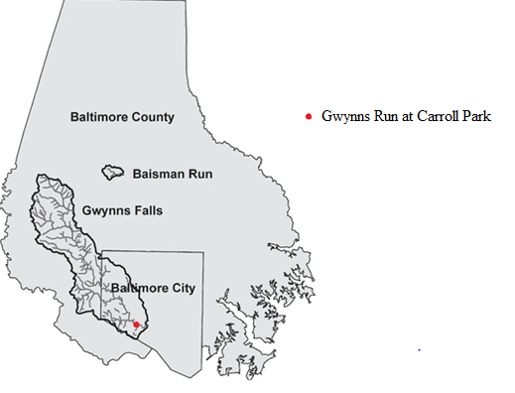
- Contact Person for Dataset:
  - Dr. Peter Groffman, BES Co-Principal Investigator, (845) 677-7600 x128, groffmanp@caryinstitute.org
  - Web information at: http://www.caryinstitute.org/science-program/our-scientists/dr-peter-m-roffman
  - Dr. Groffman specializes in soil ecology and water quality. His research focuses on the role of microorganisms in ecosystems, microbial processes, and nutrient cycling within the environment.
- Background Information
  - Increased nitrate concentrations in streams can be linked to human activity and natural processes. Runoff from lawns and agricultural land carries fertilizer, which contains nitrates. Leaking sewer pipes can also introduce nitrate into nearby water sources. The decomposition of plants and animals also releases nitrate that can enter the stream through runoff. Agriculture is the biggest source of nitrate that ends up in waterways. Since most nitrate enters the stream through nonpoint sources, meaning the contaminant enters the area through runoff or another indirect way, they are hard to control and regulate. This makes nonpoint sources the biggest contributor of nitrate pollution in streams. Nitrate levels are the lowest during the growing season, late spring and summer, when plants take up the nutrients in the soil, including nitrate, preventing it from entering streams. During the winter, when plants are dormant, nitrate concentrations are higher..
- Link to Maryland State Curriculum
  - Grade six
    - Standard 1.0, Topic B, Indicator 1.
    - Standard 6, Topic. B, Indicator 1
  - Grade seven
    - Standard 1.0, Topic B, Indicator 1.
    - Standard 6, Topic A, Indicator 1
  - Grade eight
    - Standard 1.0, Topic B, Indicator 1.
    - Standard 6, Topic B, Indicator 1

- Inquiry Idea Starters
  - Do the nitrate levels differ between the two sites? If so, what are some possible reasons why?
  - Is there a seasonal trend among the data?
- Additional Resources
  - http://md.water.usgs.gov/publications/wrir-97-4139/html.htm
    - The USGS explain how nitrates enter freshwater areas and the relationship between nitrates and pesticides.
  - http://www.beslter.org/virtual_tour/Nitrate.html
    - BES outlines the sources of nitrates and the importance of studying them in streams.

Sources
Nitrate. Maryland Geological Survey. July 30, 2016. http://www.mgs.md.gov/groundwater/nitrate.html
Secondary Drinking Water Standards. US Environmental Protection Agency. July 20, 2016. https://www.epa.gov/dwstandardsregulations/secondary-drinking-water-standards-guidance-nuisance-chemicals
Contamination of Water and Soil. Extoxnet (Oregon State University). August 2, 2016. http://extoxnet.orst.edu/faqs/safedrink/sewage.htm

