Baltimore Data Jam: Chloride Metadata
The Baltimore Ecosystem Study, BES, is a Long Term Ecological Study funded by the National Science Foundation. Their goal is to conduct long term research at ecological sites in Baltimore City and the surrounding areas. They broaden the idea of ecology to not only focus on the natural world, but include the people and the cities they live in, to better understand their role in the environment.
- Dataset Variables:
  - Site- location of sampling site
  - Date – calendar date sample was taken
  - DOY – Day of the Year (January 1 = 1, etc.)
  - Cl (mg/L) – chloride concentration
- Dataset Timeframe:
  - Dataset includes weekly samples for the year 2014
  - Additional data is available for these and other sites for more than 15 years, starting in 1998.
  - The data were published 4/5/16.
- Data Collection Methods:
  - Samples were collected by BES staff with clean plastic bottles from the same location in each stream every week.
  - Cl concentrations were measured in the laboratories of the Cary Institute.
  - Samples are collected from 23 different locations.
- Information About Sites
  - Baisman Run is located in Baltimore County in Oregon Ridge Park. The 381 hectare watershed is mostly forested with a small number of large residential properties at the top of the watershed. The stream gauge is located at Ivy Hill Road underneath the bridge.
  - Gwynns Run at Gwynns Falls sample site is located in Carroll Park. Carroll Park is located in Baltimore City in the Carroll Park Municipal golf course. The watershed is approximately 2.5 square miles and is considered an urban subwatershed. Denitrification efforts have taken place to help improve the the quality of the stream.

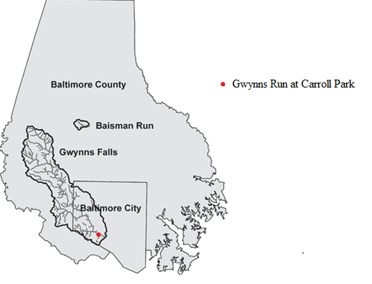

- Contact Person for Dataset:
  - Dr. Peter Groffman, BES Co-Principal Investigator, (845) 677-7600 x128, groffmanp@caryinstitute.org
  - Web information at: http://www.caryinstitute.org/science-program/our-scientists/dr-peter-m-roffman
  - Dr. Groffman specializes in soil ecology and water quality. His research focuses on the role of microorganisms in ecosystems, microbial processes, and nutrient cycling within the environment.

- Background Information
  - While salt (NaCl) occurs naturally in many soils and rocks, it is released very slowly from these sources so that in most places groundwater and surface freshwater have very low levels of chloride (Cl). People introduce much higher amounts of salt to the environment, mainly through application of de-icers on roads and parking lots, and from water softeners and other household appliances. The biggest contributor to high levels of chloride in surface water is road salt. As snow and ice melt, or rain falls on surfaces that had residual road salt, the water can carry the Cl into surface water either directly through runoff or indirectly via the groundwater. Urban areas usually have higher levels of chloride in the groundwater and surface waters draining them since they have more roads and paved areas where salt is applied.
  - Elevated levels of chloride can be harmful to organisms, from those living near paved surfaces, to those in the groundwater and surface waters. These can include plants, fish, invertebrates and microorganisms. In some cases, Cl can bio-accumulate in food webs. High levels of Cl can make water unsafe for human consumption as well. According to the EPA’s Secondary Drinking Water Standards, the Maximum Contaminant Level, or MCL, for Chloride is 250 mg/L. After this limit is surpassed, a salty taste is noticeable in the water. For seawater, the average level of chloride is around 35,000 mg/L (Columbia University).

- Link to Maryland State Curriculum
  - Grade six
    - Standard 1.0, Topic B, Indicator 1.
    - Standard 6, Topic. B, Indicator 1
  - Grade seven
    - Standard 1.0, Topic B, Indicator 1.
    - Standard 6, Topic A, Indicator 1
  - Grade eight
    - Standard 1.0, Topic B, Indicator 1.
    - Standard 6, Topic B, Indicator 1
- Inquiry Idea Starters
  - How do Cl levels compare in the two sites?
  - Are there trends in Cl levels over the seasons?
  - Do these trends differ in the different sites?
- Additional Resources
  - http://www.beslter.org/virtual_tour/Chloride.html
    - The Baltimore Ecosystem Study has compiled information about chloride and the effects of increasing salinity in freshwater streams.
  - http://www.baltimoresun.com/features/green/blog/bs-hs-salty-streams-20150102-story.html
    - The Baltimore Sun investigates the high levels of chloride in the Patuxent and Potomac Rivers and how road salt influences these increases.
  - http://www.mde.state.md.us/programs/Marylander/Pages/roadSalt.aspx
    - The Maryland Department of the Environment describes what road salt is and its effects on the natural world, especially aquatic life and overall stream health.

Sources
Columbia University. Chloride and Salinity. July 11, 2016. http://www.ldeo.columbia.edu/edu/k12/snapshotday/activities/2011/Classroom%20HS%20activity/chloride%20conversion/Chloride%20and%20Salinity.pdf
Maryland State School Curriculum. Teaching and Learning Science. July 20, 2016. http://mdk12.msde.maryland.gov/instruction/curriculum/science/
Baltimore Ecosystem Study Virtual Tour. Chloride. July 10, 2016. http://www.beslter.org/virtual_tour/Chloride.html.

