Baltimore Data Jam Methane Metadata
The Baltimore Ecosystem Study (BES) is a Long Term Ecological Research site funded by the National Science Foundation. Their goal is to conduct long term ecological research at sites in Baltimore City and the surrounding areas. BES research broadens the idea of ecology to not only focus on the natural world, but include the people and the cities they live in, to better understand their role in the environment. This data represents concentrations of methane collected from chambers at ground level at two forested and one lawn site.
- Dataset Variables:
  - Year
  - Date
  - Site: HD, ORU or UMC
  - Plot
  - Chamber
  - mg CH4/m2/d- Concentration of Methane
- Dataset Timeframe:
  - Dataset includes monthly samples for the year 2016
  - Additional data is available for years 1999-2015
- Data Collection Methods
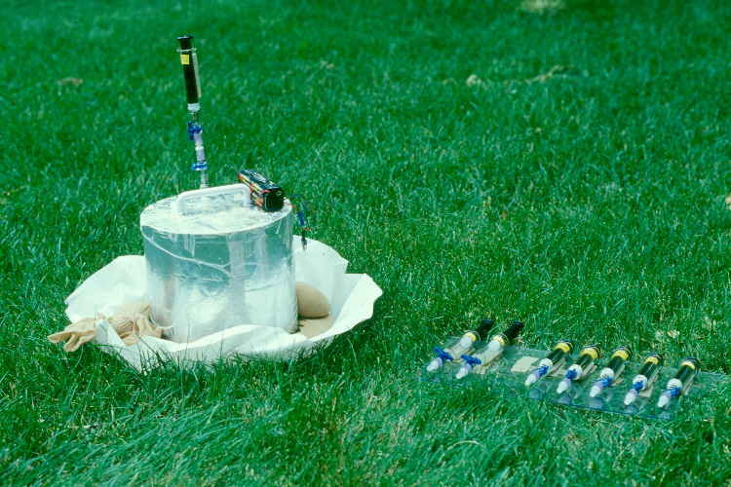
  - Data was collected by BES staff once every 4-6 weeks from an air tight chamber in each plot. 9 mL gas samples were collected from the sampling port of each chamber with a syringe.
  - Concentrations of methane were measured in the laboratories of the Cary Institute
- Information About Sites
  - (BES) has established a network of long-term permanent biogeochemical study plots. These plots will provide long-term data on vegetation, soil and hydrologic processes in the key ecosystem types within the urban ecosystem. The current network of study plots includes eight forest plots, chosen to represent the range of forest conditions in the area, and four grass plots. These plots are complemented by a network of 200 less intensive study plots located across the Baltimore metropolitan area. See Baltimore's Vegetation Structure And Its Ability To Remove Air Pollutants And Sequester Carbon Dioxide.
Plots are currently instrumented with lysimeters (drainage and tension) to sample soil solution chemistry, time domain reflectometry probes to measure soil moisture, dataloggers to measure and record soil temperature and trace gas flux chambers to measure the flux of carbon dioxide, nitrous oxide and methane from soil to the atmosphere.
  - HD: Hillsdale is a forested site located in West Baltimore City, not far from Leakin Park. Hillsdale Park is 34 acres and houses a golf course used by the surrounding community.
  - ORU: Oregon Ridge Park Upper-slope is a forested site located in between the suburbs of Reisterstown and Cockeysville, in Baltimore County. It is 1100 acres and was used in the past as a site of iron ore and marble mining.
  - UMC: University of Maryland, Baltimore County is a lawn site subject to fertilizer and herbicide application. The site is mowed biweekly.

- Contact Person For Dataset
  - Peter Groffman BES Principal Investigator, Peter.Groffman@asrc.cuny.edu, 212-413-3143 (Office)
  - http://www.caryinstitute.org/science-program/our-scientists/dr-peter-m-groffman
  - Dr. Groffman specializes in soil ecology and water quality.
- Background Information
  - Methane is a greenhouse gas, its presence in the atmosphere affects the temperature and climate of Earth. It is the second most abundant greenhouse gas and can trap heat in the atmosphere 25 times more than Carbon dioxide.
  - Methane can be emitted from human influenced and natural sources.
  - These data measure the flux of methane between the soil and atmosphere. Flux is the change in gas concentration over time.
  - Understanding methane gas flux at the landscape level is critical to understanding the drivers of climate change and well as to identify mitigation opportunities.
  - The methane flux that BES measures is “net” flux that balances anaerobic production and aerobic consumption of this gas. For example, swamps that have lots of anaerobic soils have big positive fluxes (methane is coming out of the soil and going into the atmosphere) and drier, upland soils have small negative fluxes (methane is being taken out of the atmosphere and "eaten" by soil microbes).
- Link to Maryland State Curriculum
  - High School Goal 6 Environmental Science
    - Expectation 6.3
      - The student will analyze the relationships between humans and the earth’s resources.
        - Indicator 6.3.1
          - The student will evaluate the interrelationship between humans and air quality.
            - Ozone
            - greenhouse gases
            - volatile organic compounds (smog)
            - acid rain
            - indoor air
            - human health
        - Indicator 6.3.3
          - The student will evaluate the interrelationship between humans and land resources.
            - wetlands
            - soil conservation
            - mining
            - solid waste management
            - land use planning
            - human health

- Inquiry Idea Starters
  - Given what you know about methane, why do you think it’s important to find which locations have higher concentrations of methane?
  - What type of locations would you think release higher concentrations of methane? How does this relate to climate change?
- Additional Resources
  - How to collect and analyze gas chamber data. https://www.jove.com/video/52110/measurement-greenhouse-gas-flux-from-agricultural-soils-using-static
- Sources
- Topoquest. Oregon Ridge Topographical Map. September 21, 2017.
https://www.topoquest.com/map.php?lat=39.48427&lon=-76.69386&datum=nad83&zoom=4
- Topoquest. Leakin Park Topographical Map. September 21, 2017.
https://www.topoquest.com/map.php?lat=39.48427&lon=-76.69386&datum=nad83&zoom=4
- Topozone. Hillsdale Park Topographical Map. November 21, 2017. https://www.topozone.com/maryland/baltimore-city-md/city/west-baltimore/
- Environmental Protection Agency. Importance of Methane. September 21, 2017. https://www.epa.gov/gmi/importance-methane
- USGS. Ground Water Hydrology-Unsaturated Zone Field Studies. November 21, 2017. https://wwwbrr.cr.usgs.gov/projects/GW_Unsat/

