Baltimore Data Jam: Stream Chemistry Data, 2000-2015
The Baltimore Ecosystem Study, BES, is a Long Term Ecological Study funded by the National Science Foundation. Their goal is to conduct long term research at ecological sites in Baltimore City and the surrounding areas. They broaden the idea of ecology to not only focus on the natural world, but include the people and the cities they live in, to better understand their role in the environment. These data represent stream chemistry measurements at five core sampling sites.
- Dataset Variables:
  - Date – date sample was collected
  - Year
  - Julian Date (day of year)
  - Site
  - Cl (mg/L) - chloride
  - NO3 (mg N/L) - nitrate
  - PO4 (ug P/L) - phosphate
  - SO4 (mg/L) - sulfate
  - TN (mg N/L) – total nitrogen
  - TP (ug P/L) – total phosphorus
  - Time (time of day sample was collected)
  - Temperature (degrees C)
  - Dox (mg/L) – dissolved oxygen
  - pH
- Dataset Timeframe:
  - These data were collected once weekly between 2000 and 2015.
- Data Collection Methods:
Samples are collected weekly at an established sampling location at each station. Sampling locations were chosen based on adequate concentration of flow, proximity to weir and staff gage, and low vulnerability to disturbance. Samples are collected and stored in polyethylene bottles.
Weekly analyses includes nitrate, phosphate, total nitrogen, total phosphorus, chloride and sulfate, total suspended solids, turbidity, fecal coliforms, temperature, dissolved oxygen and pH. Cations, dissolved organic carbon and nitrogen and metals are measured on selected samples. Only a subset of these parameters are included in the this data set.
Samples for anion and cation analysis are filtered (0.45 micron). Samples for total suspended solids, total N, total P, turbidity, and fecal coliform analysis are not filtered.

During weekly visits for sample collection, a handheld meter is used to get instantaneous measures of temperature, pH, conductivity and dissolved oxygen.
Every six weeks, samples are shipped to the Cary Institute of Ecosystem Studies (CIES) for anion, cation, TN, and TP analysis. TSS and turbidity analysis is done at the BES laboratory at the University of Maryland Baltimore County (UMBC).
- Anions. Concentrations of nitrate, chloride and sulfate are analyzed on a Dionex LC20 series ion chromatograph. Concentrations of phosphate are analyzed on a Lachat Quikchem 8000 flow injection analyzer.
- Total nitrogen and phosphorus are analyzed by persulfate digestion followed by analysis of nitrate and phosphate on a Lachat Quikchem 8000 flow injection analyzer. If the value for total N is more than 0.10 mg N L-1 less than nitrate-N, the total N value for that sample is set to the nitrate value. If the value for total P is more than 0.01 mg P L-1 less than the phosphate P, the total P value for that sample is set to the phosphate value.

- Information About Sites
  - GFCP – Gwynns Falls at Carroll Park - This site samples drainage from approximately 16,000 ha of mixed suburban and urban watershed. The site has been monitored by USGS since 1994 and represents the boundary condition for entire Gwynns Falls above head of tidal influence.
  - GFVN – Gwynns Falls at Villanova, located along the urban/suburban boundary
  - MCDN – McDonogh - This is an 8ha agricultural "reference" watershed located on the grounds of the McDonogh School.
  - GFGB – Gwynns Falls at Gwynbrook Road, suburban site. This stream site drains ~1,065 ha of land classified as 82% developed and 17% undeveloped.
  - GFGL – Gwynns Falls at Glyndon - This site samples drainage from approximately 96 ha of suburban land at the headwaters of our main study stream.
  - RGHT – Rognel Heights – a storm sewer outfall
  - DRKR – Dead Run at Kernan Road – Has a drainage basin of 5.52 square miles. Known for its “flashy” hydrology with large, quick flood peaks following short term rainfalls.
  - POBR – Pond Branch - This is a completely forested "reference" 41 ha watershed located in a county park.
  - BARN – Baisman Run at Ivy Hill Road, located in Oregon Ridge Park. Mostly forested watershed.
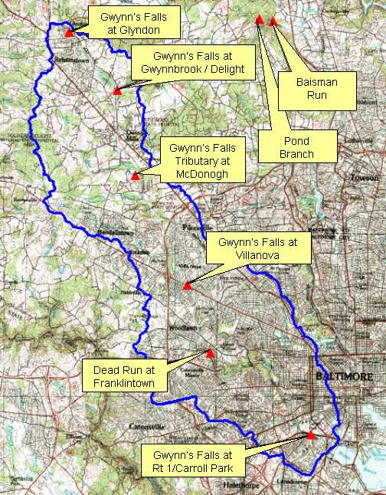
- Contact Person for Dataset:
  - Dr. Peter Groffman, groffmanp@caryinstitute.org or Dan Dillon, dillond@caryinstitute.org

- Background Information
Our long-term sampling network includes four longitudinal sampling sites along the Gwynns Falls as well as several smaller (40 - 100 ha) watersheds located within or near to the Gwynns Falls. The longitudinal sites provide data on water and nutrient fluxes in the different land use zones of the watershed (rural/suburban, rapidly suburbanizing, old suburban, urban core) and the small watersheds provide more focused data on specific land use areas (forest, agriculture, rural/suburban, urban)

BES stream chemistry samples are collected at gaging stations built and maintained by the U.S Geological Survey and which are funded mainly by LTER funds. However a number of the stations are funded by other sources, including the USGS, Maryland Department of the Environment, Baltimore County DEPRM, and Baltimore City DPW.
Stage at each gage site is measured to about 0.01 ft accuracy and is recorded at 15 minute (or shorter) intervals using either a float gage or pressure transducer. These stage records are converted to flow records using stage-discharge relationships (see below).
Crest-stage recorders (floating cork gages) indicate high water marks and provide a backup source of high water in case recording gages are compromised in flooding conditions.
Stilling wells are installed at each site, either in the channel or via piping to the channel, to provide quiescent locations for sensing of stage.

- Links to Next Generation Science Standards

HS-ESS2 – Earth’s Systems
2-2: Analyze geosciences data to make the claim that one change to Earth’s surface can create feedbacks that cause changes to other Earth systems

HS-ESS3 - Earth and Human Activity
3-5: Analyze geosciences data and the results from global climate models to make an evidence-based forecase of the current rate of global or regional climate change and associated impacts to Earth’s systes
3-6: Use a computational representation to illustrate the relationships among Earth systems and how those relationships are being modified due to human activity

LS2.C – Ecosystem Dynamics, Functioning and Resilience
2-7: Anthropogenic changed in the environment can disrupt an ecosystem and threaten the revival of some species

- Inquiry Idea Starters
  - How do nitrate levels differ across sites for the same date?
  - What might cause a spike in chloride levels at all sites on the same day?
  - Do some sites have consistently higher levels of dissolved oxygen than others?
  - Discuss your ideas for how land cover might impact the water chemistry of nearby streams.
  - What long-term trends might you expect to see in streams of watersheds that 1) are currently going through intensive development, 2) are completely undeveloped or 3) were developed over 100 years ago.

- Additional Resources
- BES Long Term Stream and Watershed Study Overview
http://beslter.org/frame4-page_3f_05.html
- Visit the BES stream sites using the Virtual Tour: https://beslter.org/virtual_tour/Index.html

