Sun and shade leaves
June 20, 2011
Gabriel Hemery
A mature and healthy tree will have many thousands of leaves, all of which need sunlight to be able to make energy for the plant through photosynthesis. A tree is remarkably ‘clever’ in managing its leaves: by altering their position, size, structure and habit.
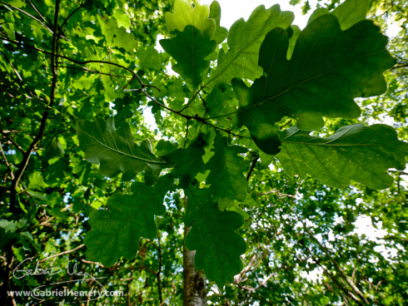
Oak sun and shade leaves. Notice how each leaf is arranged to avoid self-shading where possible on this single oak sprig. When shaded lower in the canopy the leaves are larger and darker in colour.
With so many leaves on a single tree it is inevitable that some will shade others. If a leaf is constantly shaded it will be discarded by the tree. If there is some sunlight however, even a little diffuse light (see below), then a tree makes the most of it by producing shade leaves lower down in its canopy. Shade leaves are larger and thinner than normal sun leaves, and often appear a darker green (they contain more chlorophyll). They also have half as many stomata than sun leaves, or even fewer, and so have a lower respiration rate. They can react quickly to brief bursts of sunlight and dappled shade.
Shade leaves can turn into sun leaves and visa versa; providing that the change is gradual. This is something that a gardener moving a plant outside that has been grown indoors or in the greenhouse, must be aware of. When a plant is taken outdoors, place it first under shade and gradually over several days increase its exposure to bright sunlight.

Trees are efficient in their architecture. Look carefully at a single twig and you will notice how the leaves avoid shading each other (they are often in a Fibonacci spiral), and the same applies at a bigger scale in a tree’s branches. Looking up through a canopy you can normally see the tree’s leaves and branches interlocking like a giant 3D jigsaw; admittedly rather a messy one. Some species, such as maples, will have smaller leaves with shorter petioles (leaf stalks) higher in the canopy. This helps by allowing more diffuse sunlight to pass down through the canopy. You can replicate this effect at home with a simple experiment:
In a room lit with a lightbulb, hold a small coin near a piece of paper and you will see a hard shadow on it. Move the coin nearer to the light and the shadow will become diffuse and will eventually disappear altogether.
This is because the lightbulb is a disc of light, like our sun, rather than a single point of light. In a tree canopy, the arrangement of branches can create space between layers of leaves, and this distance (rather like in our coin experiment), allows more diffuse light to pass through the canopy.
Some tree species are more tolerant of shady conditions. Such species, capable of growing under mature forest canopies, often have a single plane of leaves when young to maximise use of the low light levels. Examples of shade-tolerant species include basswood (Tilia americana), beeches (Fagusspp.), hemlocks (Tsuga spp), some maples (Acer spp) and spruces (Picea spp).
Now you can look at a tree and its leaves in a new light (sorry couldn’t resist!).
http://gabrielhemery.com/2011/06/20/sun-and-shade-leaves/

